BOLTA ELECTRIC (SHENZHEN) CO.,LTD

CUSTOMER

： 有限公司

Name: Latching Relay P/N：BDJ011-120A-009
SPEC：120A/250VAC File Version： 2018112301
Date： 2018.11.23

Customer Signature

Y M D

Address: 601-604, Bldg 150, Guanlongcun East, Xili, Nanshan,Shenzhen, China
Tel: (+86)755-86599556

- Product Name | Three-phase Latching Relay
1.1 Type | BDJ011-120A-009
1.2 Outline Dimensions | 24mm×23.5 mm×20 mm
1.3 Product Weight | 30g
Contact Specification
Contact Arrangement | 1Form B
Contacts Gap | 0.7 mm Minimum
Contact Pressure | ＞500g
Contact Material | Silver Alloy---AgSnO2
Contact Resistance | Maximum 0.4mΩ at initial value  Test current 120A, Open circuit test voltage1V ～12V  By using Voltage Drop Method
Contact Capacity | 120 Amps at 250VAC Cosθ=1
Impact Current | Relay should not explosive or in fire after 3 times 10ms current impacts of 6000A. Meets the IEC-62055-31 UC3 standard.
Max Switching Voltage | 440VAC
Coil Specification at 20 °C
Rated Voltage | 9VDC
Rated Width of Input Pulse | 100ms
Max Width of Input Pulse | 200ms  Note: Input pulse over 200ms may cause a malfunction of relay
Nominal Current
Rated Power Consumption
Pull In Voltage | ≥6.3VDC
Drop Out Voltage | ≥6.3VDC
Max. Allowable Voltage | 20VDC
Motor Coil Resistance | 13Ω ±10%
Operate Time | Maximum 100 milliseconds when Rated Voltage is applied
Release Time | Maximum 100 milliseconds when Rated Voltage is applied
Electrical Characteristics
Life Expectancy
Electrical Life | Minimum 5,000 operations. 120A/250VAC Cosθ=1, Minimum 5,000 operations. 120A/250VAC Cosθ=0.5  Cycled at 10 seconds rated load current and 20 seconds without rated load current.
Mechanical Life | Minimum 100,000 operations at Off Load Condition with frequency of 0.5Hz.
Overload
100 operations. 180A/250VAC Cosθ=1
Cycled at 10 seconds rated load current and 20 seconds without rated load current. The relay satisfies the requirement of the specification.

- Maximum Operating Frequency | Electrical 20 operations/minute  Mechanical 30 operations/minute
- Temperature Rise | Load rated current of 120A for 2 hour, temperature rise of the short load terminal lower than 65K.
- Heat | Load rated current of 120A for 2 hours, Q<200J in one minute.
  - Dielectric Strength
- Between Contacts | 2000VAC 50/60 Hz, lasts for 1 minute and the leakage current less than 1mA.
- Between Motor & Contact | 5,000VAC 50/60 Hz, lasts for 1 minute and the leakage current less than 1mA.
- Between two phase | 5,000VAC，50/60 Hz，lasts for 1 minute and the leakage current less than 1mA.
- Insulation Resistance | ≧1000 MΩ, A Voltage of 500VDC should be applied after which measurement shall be made.
- Vibration | No power supply to the relay, vibrates at 60Hz with double amplitude 0.075 mm. This motion shall be applied for a period of 1.5 hours in each of 3 mutually perpendicular axis (a total of 4.5 hours). There should not be any deformations in construction and in appearance, while the Electrical specifications should be fulfilled after the test.
- Shock | Peak Acceleration 150m/s²  No power supply to the relay, 5 successive shocks shall be applied in 3 mutually perpendicular axis. There should not be any deformations in construction and in appearance while the Electrical specifications should be fulfilled after the test.
- Environmental Characteristics
  - Temperature Range
- Operating Temperature | -40 to + 85°C, Operating temperature range is the range of ambient temperature of which the relay can be operated continuously.
- Storage Temperature | -40 to + 85°C, Storage temperature range is the range of ambient temperature of which the relay can be stored without damages (No condensation of water drops under low temperature condition).
- Humidity | Operating relative humidity range from 5~95%RH
  - Cold Resistance
- Cold Resistance in Use | At -40 ± 2°C for two hours，the relay operates normally once every one minute at rated supply voltage. The Electrical specifications of contact voltage drop should be fulfilled one hour after the relay was taken out of the temperature chamber and under standard atmospheric condition.
- Storage Cold Resistance | Relay should be kept in temperature chamber at -40 ± 2°C for 72 hours. Then the relays shall be maintained at standard atmospheric condition for 1 to 2 hours after which measurement shall be made. Construction, Relay operation, Insulation Resistance and Dielectric Strength shall satisfy the Specification requirements. (No condensation of water drops under low temperature condition)
  - Heat Resistance
- Heat Resistance in Use | At +85± 2°C for two hours，the relay operates normally once every one minute at rated supply voltage. The Electrical specifications of contact voltage drop should be fulfilled one hour after the relay was taken out of the temperature chamber and under standard atmospheric condition.
- Storage Heat Resistance | Relay should be kept in temperature chamber at +85 ± 2°C for 48 hours. Then the relay shall be maintained at standard atmospheric condition for 1 to 2 hours after which measurement shall be made. Construction, Relay operation, Insulation Resistance and Dielectric Strength shall satisfy the Specification requirements.
- Moisture Resistance | Relay should be kept in temperature chamber at +85 ± 2°C (85% RH) for 1000 hours. Then the Relays shall be maintained at standard atmospheric condition 2 hours before all the tests be made. Construction, Relay operation, Insulation Resistance, Dielectric Strength shall satisfy the Specification requirements.
- Terminal Characteristics
- Terminal Strength | A load strength of 10Kg·cm should be applied to the Load Terminals for one minute in horizontal direction. There should not be any looseness of the Load Terminals.
- Soldering Dip Test | The front 3 mm of drive input and sensing terminals should be immersed into soldering pot for 3 ± 0.5 seconds at 260 ± 5°C. Soldered area must be more than 90% of the soldering surface.
- Stress Test | Load rated current 120A for 0.5 hour, a load strength of 3Kg·cm should be applied to the two Load Terminals in each of 3 mutually perpendicular axis. The contact drop voltage and contact pressure should be fulfilled the requirements of specification.
- Shunt | Customized
8. Flame-Retardant | Use 960℃ hot wire, ignite the shell of relay for 30 seconds and take away the hot wire. The flame of the shell goes out less than 10 seconds.
9. Sample Test Method | Chinese standard GB/T 2828.1, Level – General II, AQL 0.4.
10. Naming
BDJ011 | - | 120A | - | 009
 |  |  |  |  |  |  |  | Rated Driving Voltage 9V
 |  |  |  |  |  |  |  | Load Capacity 120A
 |  |  |  |  |  |  |  | Bolta Type

11. Outline and working diagram
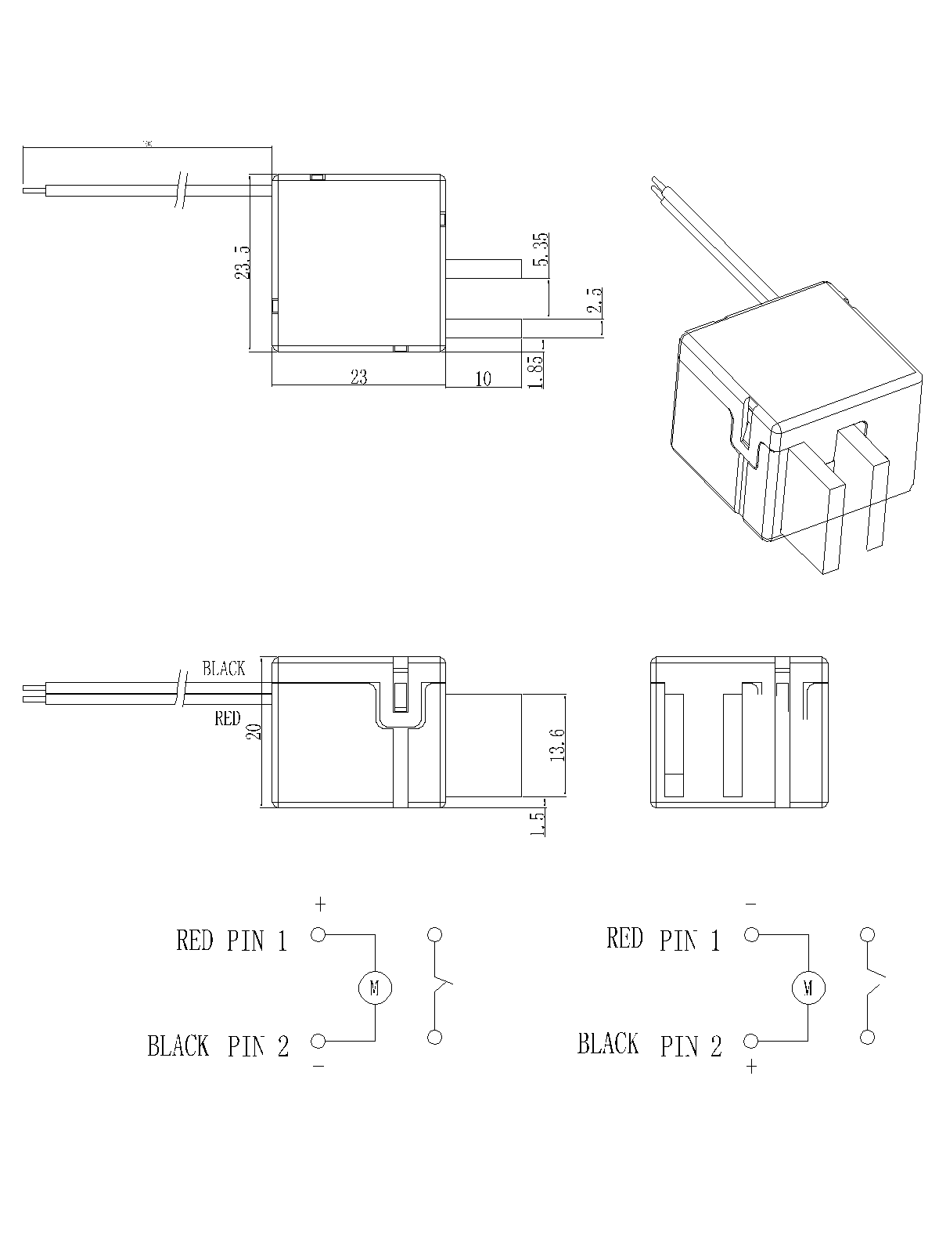
Note：Length, color of lead wires and some other specs can be customized by the order request.

