BOLTA ELECTRIC (SHENZHEN) CO., LTD

SPECIFICATION

： 有限公司

NAME： Latching Relay P/N：BDJ006-120A-009
SPEC： 120A/250VAC (13Ω) SHUNT：/uΩ
VERSION： 20170522

CUSTOMER:

Year Month Day

Address: 601-04, Bldg 150, East Guanlongcun, Xili,Nanshan District, Shenzhen, Guangdong, China
Tel: 0755-86599556, 86599558,
Postal Code: 518055

Product Name | Latching Relay
1.1 Type | BDJ006-120A-009
1.2 Outline Dimensions | 35.5×35×23.8mm
1.3 Weight(g) | 40±1g
- Contact Specification
Contact Arrangement | 1 Form B
Contacts Gap | Minimum 0.70mm
Contact Pressure  And material | 500-600g or 4.9-5.88N AgSnO2
Immune to strong magnetic field | 500 militesla (Working well, latching well by over 500militesla magnets when 6 faces of the meters were interfered)
Contact Resistance | Maximum 0.3mΩ at initial value  Test current 120A, Open circuit test voltage 1V ～12V  By using Voltage Drop Method (Shunt resistance excluded)
Contact Capacity | 120 Amps at 250VAC Cosθ=1
Surge Current | Relay should not fire or exploded after 3 times 10ms current impacts of 6000A and 10000A. In accordance with IEC62055-31 UC3 and UC4 standard.
Max Switching Voltage | 440VAC
Specifications
Rated Voltage | 9VDC
Rated Width of Input Pulse | 100ms
Max Width of Input Pulse | 200ms  Note: Input pulse width over 200ms may cause a malfunction of relay.
Nominal Current | Start at 693mA±10%，10ms later 412mA±10%，  20ms later 294mA±10%，30ms later 176mA±10%，  40ms later 117mA±10%  50ms later kept at 88mA±10%
Rated Power Consumption | 1.7W±10%
Max. Allowable Voltage | 30VDC
Relay Coil Resistance | 13Ω ±10%
Operating Time | Maximum 80milliseconds when Rated Voltage is applied, .
Releasing Time | Maximum 50milliseconds when Rated Voltage is applied,
- Electrical Characteristics
Working Cycles Expectancy
Electrical Cycles | 5,000 Operations at 120A/250VAC, Cosθ=1, followed by 5,000 Operations at 120A/250VAC, Cosθ=0.5,  Cycled at 10 seconds rated load current and 20 seconds without rated load current. In accordance with UC3 standard.
Mechanical Cycles | Minimum 100,000 operations at Off Load Condition with frequency of 0.5Hz.
Overload
100 operations. 180A/250VAC Cosθ=1
Cycled at 10 seconds rated load current and 20 seconds without rated load current. The relay satisfies the requirement of the specification.

Maximum Operating Frequency | Electrical 20 operations/minute  Mechanical 30 operations/minute
Temperature Rise | Load rated current of 120A for 2 hour, temperature rise of the short load terminal should lower than 65K.
Heat | Load rated current of 120A for 2 hours, Q<180J in one minute.
Dielectric Strength
Between Contacts | 2000VAC 50/60 Hz, lasts for 1 minute and the leakage current less than 1mA.
Between Signal-lines & Contacts | 4,000VAC 50/60 Hz, lasts for 1 minute and the leakage current less than 1mA.
Insulation Resistance | ≧1000 MΩ, A Voltage of 500VDC should be applied after which measurement shall be made.
Vibration | No power supply to the relay, vibrates at 60Hz with double amplitude 0.075 mm. This motion shall be applied for a period of 1.5 hours in each of 3 mutually perpendicular axis (a total of 4.5 hours). There should not be any deformations in construction and in appearance, while the Electrical specifications should be fulfilled after the test.
Shock | Peak Acceleration 150m/s²  No power supply to the relay, 5 successive shocks shall be applied in 3 mutually perpendicular axis. There should not be any deformations in construction and in appearance while the Electrical specifications should be fulfilled after the test.
Environmental Characteristics
Temperature Range
Operating Temperature | -40 to + 85°C, Operating temperature range is the range of ambient temperature of which the relay can be operated continuously.
Storage Temperature | -40 to + 85°C, Storage temperature range is the range of ambient temperature of which the relay can be stored without damages (No condensation of water drops under low temperature condition).
Humidity | Operating relative humidity range from 5~95%RH
Low Temperature
Low Temperature Operations | At -40 ± 2°C for two hours，the relay operates normally once every one minute at rated supply voltage. The Electrical specifications of contact voltage drop should be fulfilled one hour after the relay was taken out of the temperature chamber and under standard atmospheric condition.
Low Temperature  Storage | Relay should be kept in temperature chamber at -45 ± 2°C for 72 hours. Then the relays shall be maintained at standard atmospheric condition for 1 to 2 hours after which measurement shall be made. Construction, Relay operation, Insulation Resistance and Dielectric Strength shall satisfy the Specification requirements. (No condensation of water drops under low temperature condition)
High Temperature
High Temperature Operations | At +85 ± 2°C for two hours，the relay operates normally once every one minute at rated supply voltage. The Electrical specifications of contact voltage drop should be fulfilled one hour after the relay was taken out of the temperature chamber and under standard atmospheric condition.
High Temperature Storage | Relay should be kept in temperature chamber at +100 ± 2°C for 48 hours. Then the relay shall be maintained at standard atmospheric condition for 1 to 2 hours after which measurement shall be made. Construction, Relay operation, Insulation Resistance and Dielectric Strength shall satisfy the Specification requirements.
Moisture Resistance | Relay should be kept in temperature chamber at +85 ± 2°C (90~95% RH) for 1000 hours. Then the Relays shall be maintained at standard atmospheric condition 2 hours after which measurement shall be made. Construction, Relay operation, Insulation Resistance, Dielectric Strength shall satisfy the Specification requirements.
Terminal Characteristics
Terminal Strength | A load strength of 10Kg·cm should be applied to the Load Terminals for one minute in horizontal direction. There should not be any looseness of the Load Terminals.
Lead Wire Soldering Dip Test | The front 3 mm of drive input and sensing terminals should be immersed into soldering pot for 3 ± 0.5 seconds at 260 ± 5°C. Soldered area must be more than 90% of the soldering surface.
Terminal Stress Test | Load rated current 120A for 0.5 hour, a load strength of 3Kg·cm should be applied to the two Load Terminals in each of 3 mutually perpendicular axis. The resistance of two contacts should lower than 1.0mΩ and contacts pressure should be fulfilled the requirements of specification.
Lead Wire Strength | A load strength of 1.50Kg should be applied to all the lead wire for 3 seconds, no lead wire should be damaged.
Shunt Resistance | /uohm±10%.
Flame-Retardant | Use 960℃ hot wire, ignite the shell of relay for 30 seconds, the visible flame of the fire should extinguished within 10 seconds since the hot wire taken away.
Sample Test Method | Chinese standard GB/T 2828.1, Level – General II, AQL 0.4.
Naming

BDJ006 | - | 120A | - | 009
 |  |  |  |  |  | 9V Rated supply voltage
120A
Rated load current
 |  |  |  |  |  | BOLTA type

11.
Outline and working diagram
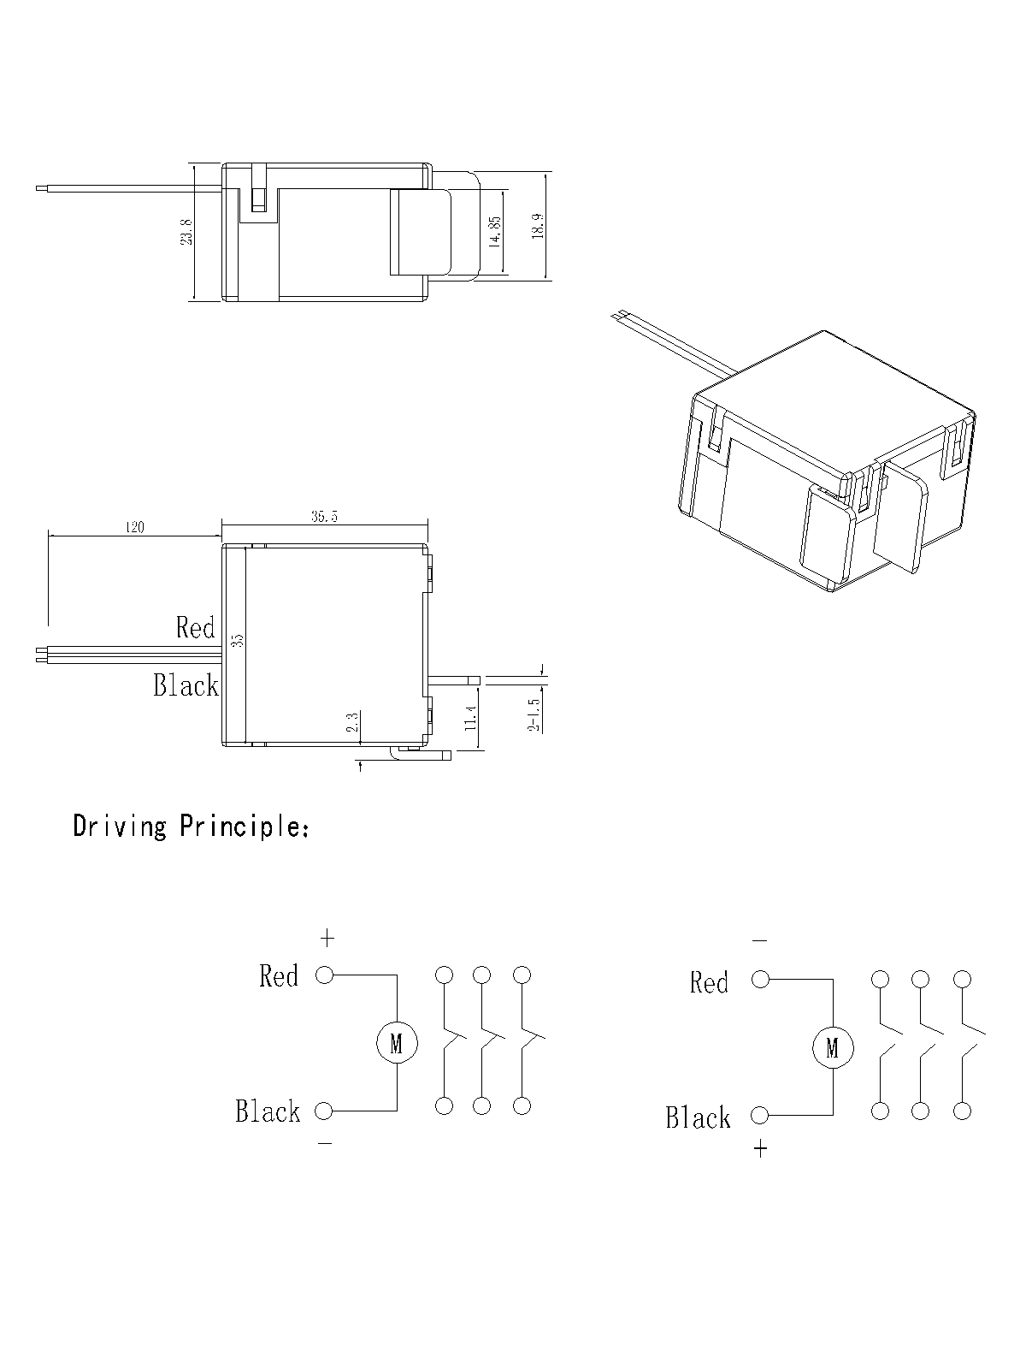

Note: Resistance of shunt, the color and length of lead wires may customized to special requisition.

